Figure Me Out
Due: Monday, August 10, 2015
On the piece of scrapbook paper you were provided (or one of your own), you will display at least 10 different facts about yourself that include numbers. Some examples might be:

- Age
- Shoe size
- Number of states visited
- Birthdate and/or Month
- Number of pets
- Number of siblings

The twist is, for each number, you will cover it with a post-it on which is written a multiplication or division fact that equals the number underneath (see the example below). You need to have 5 multiplication and 5 division facts. You may NOT use a fact that multiplies or divides by 1.
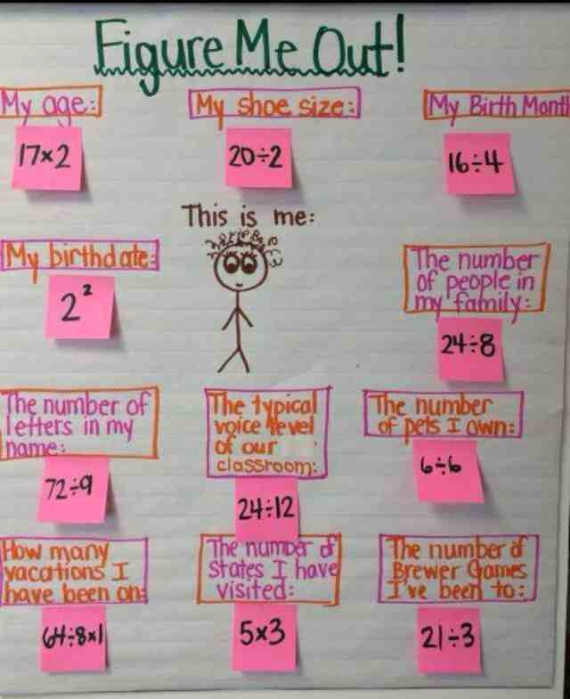
Be creative! Use/draw pictures! Use color!

